Structure of a Company Web site

A professionally appealing web site with the following pages
- Index/Home
- About us
- Leadership
- Services
- Clients
- Associates
- Contact
We have a logo that has to be incorporated and the colour theme of the site has to be in lines with the logo.
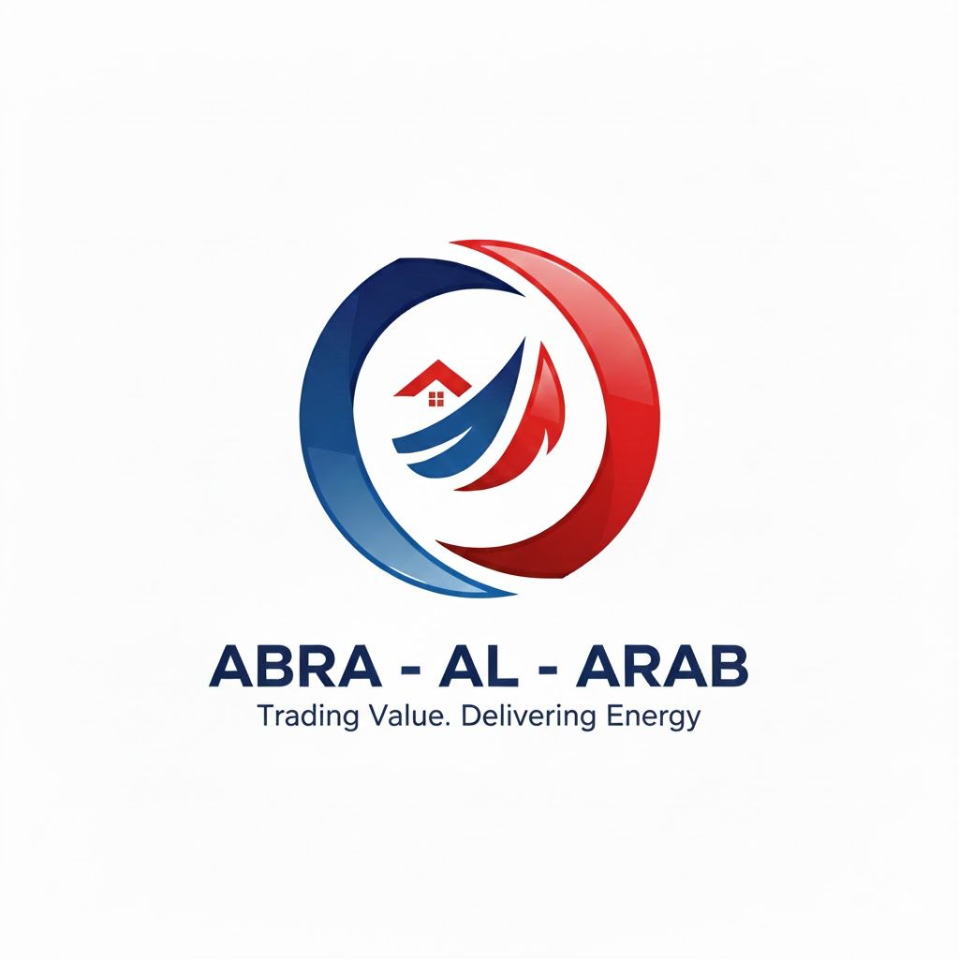
Details of the pages are given below

1. Home / Index
- Hero block (full-width banner)
  - Title: “Abra Al Arab – A reliable, ethical and dependable partner for your Petroleum Needs”
  - Sub-headline: “Connecting reliable producers of refined oil products, crude oil, diesel, lubricants, tar and asphalt with customers across the Middle East, Africa and Asia through safe, efficient and compliant supply chains”
- Six key pillars (icons in a row)
  - Diesel Fuel Trading
  - Refined Oil Products Trading
  - Tar & Asphalt Trading
  - Onshore Refined Oil Product Trading
  - Offshore Crude Oil Trading
  - Lubricants & Grease TradingQuick navigation tiles
- About Abra Al Arab
  - Leadership
  - Services
  - Clients & Sectors
  - Sustainability & Compliance
  - Contact & Trade Enquiries

2. About us
- Who we are
“Abra Al Arab is a UAE-headquartered energy trading company focused on physical trading of refined oil products, crude oil, diesel fuels, lubricants, greases, bitumen, tar and asphalt.”
“From Dubai, the company links regional and international refiners, national oil companies and distributors, deploying storage, shipping and market expertise to move vital energy products where they are needed most.”
- What we do
  - Source, store, blend and transport crude and refined petroleum products.
  - Structure supply contracts, off-take agreements and term deliveries tailored to customer needs.
  - Coordinate marine and onshore logistics through a network of terminals, storage and shipping partners.
- Vision, mission, values
  - Vision: “To be a trusted regional partner in oil and petroleum products trading, recognized for reliability, safety and sustainable value creation.”
  - Mission: “To deliver secure, competitive and responsible energy supply solutions, using market insight and logistics capabilities to make supply chains more efficient and resilient.”
  - Values: safety, integrity, compliance, partnership, performance and innovation, reflecting best practice among leading trading and upstream companies.

3. Leadership Team
Abra Al Arab is managed by a seasoned leadership team with experience across crude and product trading, upstream operations, shipping, finance and risk management.”

4. Services

4.1 Services overview paragraph
Abra Al Arab provides a full suite of oil and petroleum product trading services, from sourcing and aggregation through storage, blending, quality control, logistics and delivery, supported by market-based pricing and risk-management tools.

4.2 Detailed service matrix (for a dedicated Services page)
Service | What it includes (website copy)
Diesel Fuel Trading | Supply of automotive and industrial diesel grades for transport fleets, power generation, marine and construction segments, aligned with local specifications.
Refined Oil Products Trading | Trading of gasoline, jet fuel, gasoil and fuel oils sourced from regional and international refiners and supplied to distributors, utilities and industrial consumers.
Tar & Asphalt Trading | Provision of bitumen, tar and asphalt grades in bulk or containerized form for road building, roofing and civil infrastructure projects.
Onshore Refined Oil Product Trading | Domestic and cross-border deliveries using terminals, pipelines and trucking, offering term and spot supply options with quality and volume assurance.
Offshore Crude Oil Trading | Sourcing, aggregation and sale of crude oil cargoes via seaborne logistics, arranging FOB/CIF structures and coordinating with refineries and trading houses.
Lubricants & Grease Trading | Distribution of automotive, industrial and marine lubricants and greases, including premium and value ranges designed for different duty cycles and environments.

4.3 Supporting capabilities
- “Storage & blending in strategic hubs to optimize product quality, timing and freight.
- “Integrated marine logistics, including chartering, bunkering coordination and documentation.”
- “Price risk management through structured contracts and hedging linked to international benchmarks.”

5. Clients
- Who we serve
  - National and independent oil companies seeking flexible off-take and supply solutions.
  - Regional fuel marketers, bunkering companies and fleet operators requiring reliable diesel and lubricant supplies.
  - Construction and infrastructure contractors using bitumen, tar and asphalt for road and civil projects.
  - Industrial users and power producers needing steady deliveries of fuel oil, gasoil and specialty products.
- Client relationship philosophy
“Abra Al Arab focuses on multi-year relationships built on dependable execution, competitive pricing, transparent documentation and proactive communication.”
- “The company mirrors the governance, ESG and reporting expectations of leading global energy players to remain a partner of choice for international and regional counterparties.”

6. Our Associate Companies
a. Aroos – Al – Mohit
Chartering (Ship Rental Intermediary) & Freight Brokerage. Efficient and reliable freight solutions for your business. For trade enquiries, contact https://aroosalmohit.com/
b. Renewable Energy
Our Associate Company, Rayenna Energy is a leading provider of innovative solar energy solutions dedicated to transforming the way you harness and use energy. Learn More

7. Contact
- Contact header text
“For product enquiries, RFQs, joint-venture discussions or general information about Abra Al Arab’s trading activities, please get in touch.”
- Suggested layout
  - Office M20, MEZZANINE FLOOR, AL DANA CENTRE, MAKTOUM STREET, DEIRA, DUBAI. UAE.
  - business@aroosalmohit.com
  - Phone numbers and office hours - +971 55 9525691
    - Mon - 09:00 am – 05:00 pm
    - Tue - 09:00 am – 05:00 pm
    - Wed - 09:00 am – 05:00 pm
    - Thu - 09:00 am – 05:00 pm
    - Fri - 09:00 am – 05:00 pm
    - Sat - Closed
    - Sun - Closed
  - Embedded enquiry form with fields for:
    - Name, Company, Country, Email, Phone
    - Product interest (Refined Products / Crude Oil / Diesel / Lubricants / Tar & Asphalt / Other)
    - Expected volumes & delivery terms (Spot / Term, Onshore / Offshore)
    - Free-text message
- Compliance note (small footer text)
“All enquiries and counterparties are subject to internal KYC, sanctions screening, credit assessment and HSE standards, consistent with global commodity trading practices.”

